MAJOR Proposed Windfarm- Overlooking Inverarnie & Farr

Strathnairn: Save Our Skies -
Deadline 16-Jun-2025

Lynemore Windfarm is a proposed development of fourteen wind turbines (200m height), Battery Energy Storage System (BESS), associated infrastructure, and ancillary development.

https://www.energyconsents.scot/ApplicationDetails.aspx?cr=ECU00005105

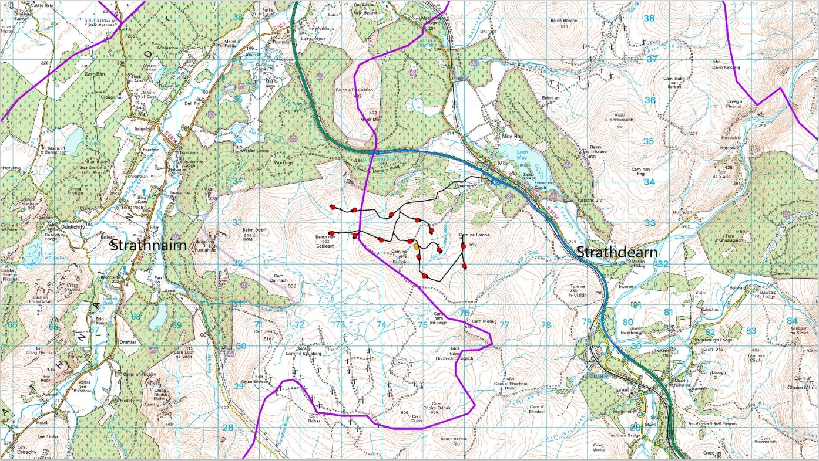

While we have many wind turbines in and around Strathnairn, the proposed turbines will be the first of this magnitude in height in the Highlands (current turbines are 100m). These 200m Turbines will require overnight industrial lighting.

Whilst we need to look at what may be positive, we also need understand what negatively affects the community, landscape, heritage, or the people when considering what is proposed and what is at risk locally or in a wider context.
In addition, understanding thresholds of what is an ‘acceptable’ amount of change.

The recent work at Aberarder Wind Farm (12 turbines at 130m) has resulted in the main route through Strathnairn (B851) having industrial lorries at a rate of one every 3 minutes during Construction periods. The B851 is largely single track and the track usage levels and near miss accidents are having an effect on the community.
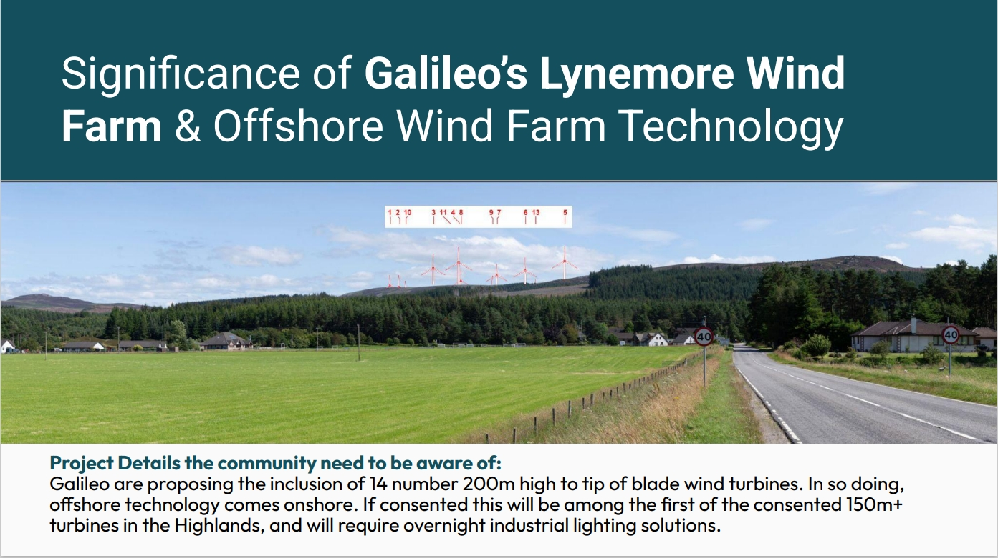

The Energy Consents Unit (ECU) invites people to submit representations, an opportunity to give a perspective as someone who knows the area which can help inform the ECU on their decision-making process. Submissions sent to the ECU are shared to the Highland Council. Once it has gone live, there are only 30 days to send an email.

Your representation can comment, support, or object to a proposed development.

- A representation has to be sent by email, with several key MUST HAVES to make it count as a representation.

- State the ECU reference in the subject header and the name of the application

- Important: begin with the words ‘I support …’ or ‘I object …’

- Be specific about your reasons referring to aspects of the planning application (cumulative effects/noise etc)

- State your name and address in block capitals

E.g.,

To: Representations_Mailbox@gov.scot

Subject: ECU00005105 (Lynemore Wind Farm)

‘I support …’ or ‘I object …’ because…..

Reasons given

YOUR NAME AND SURNAME
ADDRESS
POSTCODE

Regards, name

Community matters can directly or indirectly impact you and your neighbouring communities; specifically planning development. SCC’s website is a good starting point (www.strathnairn.org).

Do you think this will impact you, your neighbour, your visitors, your friends?

Join the conversation locally, see things from multiple perspectives, but form a view of your own. Be curious, ask questions. Think about your needs, the communities needs and those of future generations.

Make an individual representation, on each and every application as it comes forward, if you can.

A cumulative effect of a different kind worth considering

The change you can make as an individual is to engage in the process on behalf of your community.

Or remain silent /disengaged/disconnected and simply accept the outcomes. It’s entirely up to you.

Things to consider:
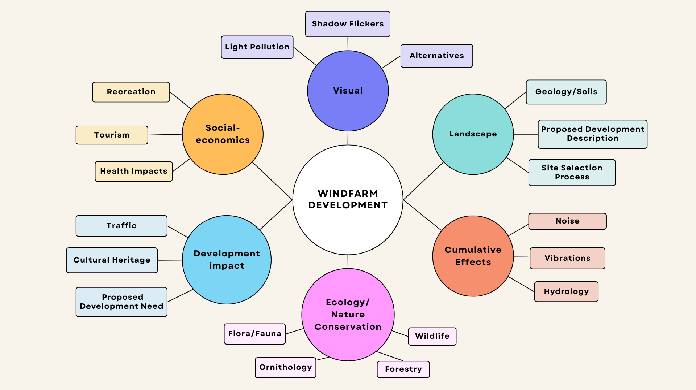

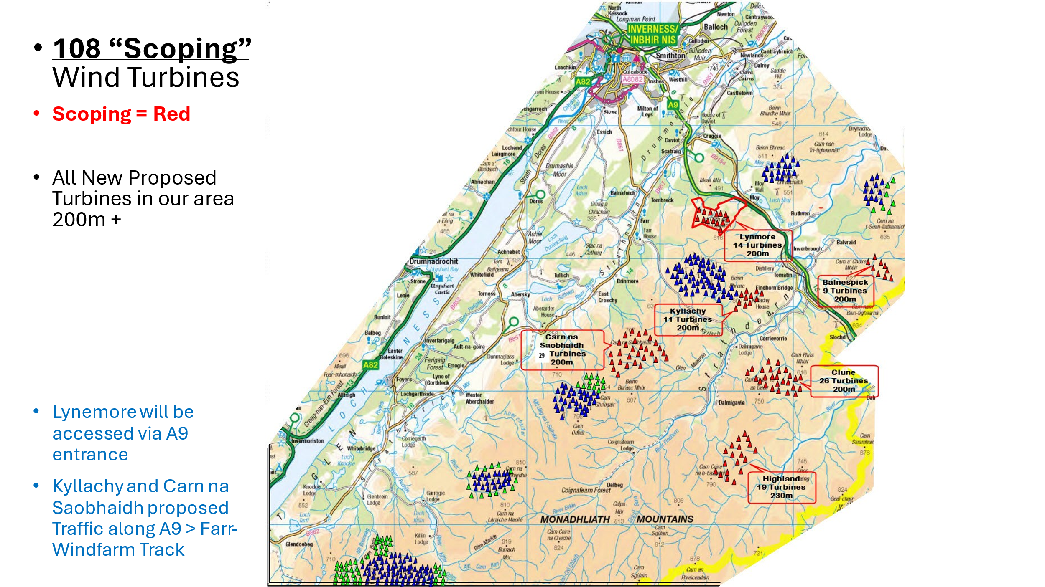
Blue: Active (215 turbines, Max height 117m)
Green: Consented (76 turbines, Max height 149.9m)
Red: Scoping in progress (108, with a height of 200m)

